Multiple choice section

|  |  |  |  |  |  |  |  |  |  |  |  |  |
| --- | --- | --- | --- | --- | --- | --- | --- | --- | --- | --- | --- | --- |
| Question | 1 | 2 | 3 | 4 | 5 | 6 | 7 | 8 | 9 | 10 | 11 | 12 |
| Answer | A | C | C | B | A | B | B | A | B | C | C | D |

Question 1 [1.5]

A

9 + 6 − 4 × 2

= 9 + 6 − 8

= 7

Question 2 [2.3]

C

224 = 2 × 2 × 2 × 2 × 2 × 7

Question 3 [2.6]

C

6 + (-2) − (-3)

=6 − 2 + 3

= 7

Question 4 [3.4]

B



Question 5 [4.9]

A

Non-Japanese : Japanese

= 10 : 15

= 2 : 3

Question 6 [4.10]

B



Question 7 [5.4]

B

n = 15 − 2 × 3

= 15 − 6

= 9

Question 8 [6.1]

A

Change all measurements to metres.

200 cm = 200 ÷ 100 m = 2 m

0.0006 km = 0.0006 × 1000 m = 0.6 m

2 + 0.3 − 0.6 = 1.7 m

Question 9 [7.4]

B



2x = 24

x = 12

Question 10 [9.4]

C

The total number of students is 126.  
Musicals represent:





Question 11 [10.1]

C

For the first value, a negative means left, so 3 units left.  
For the second value a negative means down, so 2 units down.

Question 12 [10.3]

D

The two angles would need to add to 360°, so 260°.

Multiple choice total marks: 12

Short answer section

Question 13 6 marks [1.2]

|  |  |  |
| --- | --- | --- |
| (a) 33 + 22 = 27 + 4 = 31 | (b) 42 × 33 = 16 × 27 = 432 | (c) 52 − 14 + 33 = 25 − 1 + 27 = 24 + 27 = 51 |

Question 14 6 marks [2.1]

(a) (i) LCM: 30 (ii) HCF: 1

(b) (i) LCM: 36 (ii) HCF: 1

(c) (i) LCM: 30 (ii) HCF: 5

Question 15 9 marks [3.7]

|  |  |  |
| --- | --- | --- |
| (a) –÷ = –÷ =–× = – = – = | (b) × (–) = × (–) = × (–) = × = × = | (c) ×+÷ =×+÷ =+× =+ =+ = = |

Question 16 3 marks [4.4]

(a)



(b)



(c)



Question 17 4 marks [5.8]

(a)–(b)

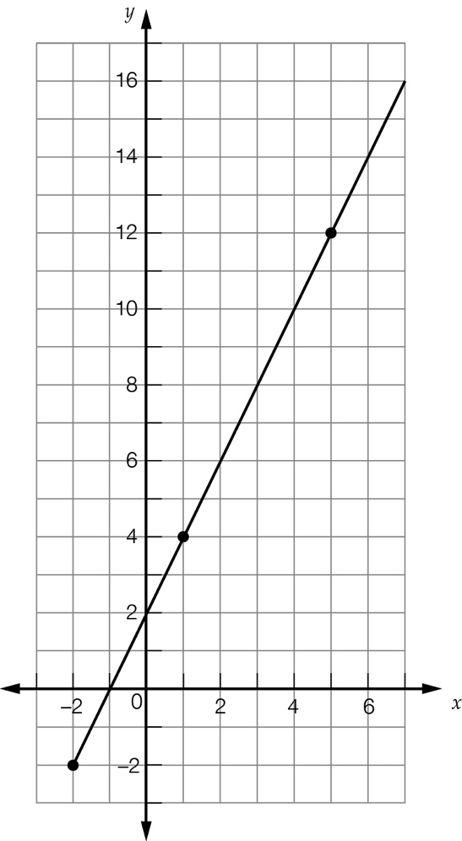

(c) 8  
 The line passes through the point (3, 8).

(d) -1  
 The line passes through the point (-1, 0).

Question 18 4 marks [5.9]

(a) Height is on the horizontal axis, the further to the right the taller the person: A B C E D

(b) Arm span is on the vertical axis, the further up the longer the person’s arm span: A C/D E B

(c) Caitlyn and Desdemona have the same arm span.

(d)

F

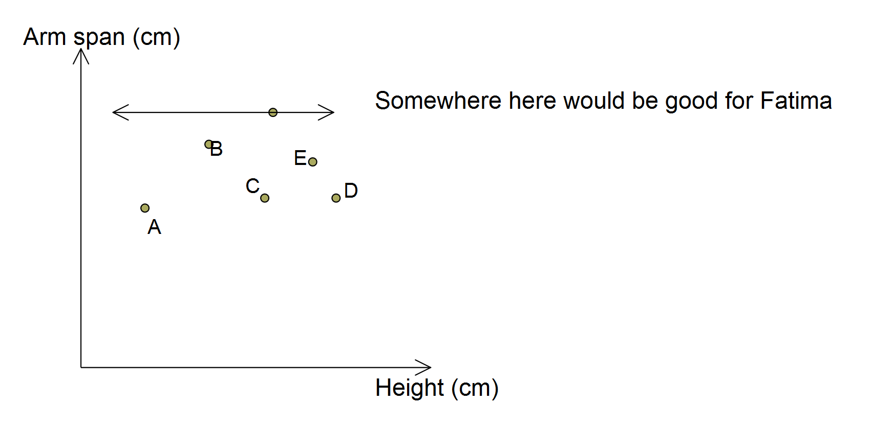

Question 19 3 marks [6.6]

Break the solid into pieces:

Volume = (1 + 1 + 14 + 5) cm3 = 21 cm3

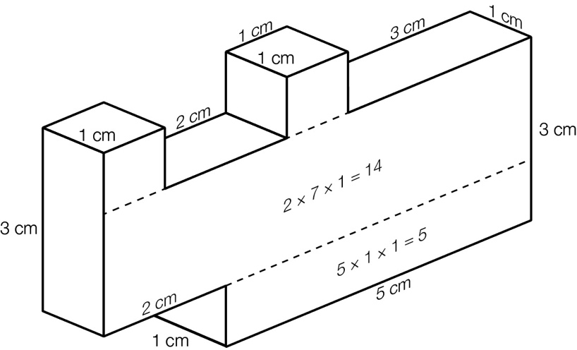

Question 20 4 marks [7.5]

|  |  |
| --- | --- |
| (a) 110p + 450 = 12 000 110p = 11 550 11p = 1155 p = 105 105 people attended the reception. | (b) 10 000 − 450 = 9550 9950 ÷ 110 = 86 with some remainder  There can be no more than 86 guests if the cost is to be less than $10 000. |

Question 21 6 marks [8.3]

(a) 180 − 90 = 90  
90 − 31 = 59  
x = 59°

(b) 70 + 61 + c = 180  
c = 49°  
a = 70°  
b = 61 + 49 = 110°

(c) 90 − 24 = 66  
a = 33°

Question 22 6 marks [8.7]

Sample answers:

|  |  |  |
| --- | --- | --- |
| (a)  PM7_SmB_ES_2 | (b)  PM7_SmB_ES_3 | (c)  PM7_SmB_ES_4 |

Question 23 6 marks [9.2]

(a) Add together all the values and divide by 12:  
 = 160.63 m.

(b) MCG, ANZ Stadium and Metricon Stadium are all equally close.

(c) Put the widths in order:  
115, 118, 122.4, 128.8, 133, 134, 135, 136, 138, 138.4, 141, 165  
The middle is between the 6th and 7th:  
134 and 135  
Median is 134.5 m

(d) Metricon Stadium and TIP Stadium are equally close.

Question 24 3 marks [9.7]

(a) A, E, N, O, P, R, S

(b) 

(c) 

Question 25 4 marks [10.5]

|  |  |
| --- | --- |
| (a)  PM7_SmB_ES_5 | (b)  PM7_SmB_ES_6 |

Short answer total: 64

Extended answer section

Question 26 5 marks [2.7]

(a) Over 1: 1 + 1 − 5 + 4 − 5 + 2 = -2  
Over 2: -5 + 2 + 4 + 4 + 1 + 1 = +7  
Over 3: 1 + 2 + 4 − 5 − 5 + 1 = -2  
Over 4: 1 + 1 + 1 − 5 − 5 + 1 = -6  
So, at end of Over 1 the score was 23, at the end of Over 2 it was 30, at the end of Over 3 it was 28 and at the end of Over 4 it was 22.

(b) In total, this pair cost the team 3 runs (-3).

Question 27 6 marks [10.7]

|  |  |  |
| --- | --- | --- |
| (a)  PM7_SmB_ES_7 | (b)  PM7_SmB_ES_8 | (c)  PM7_SmB_ES_9 |

Question 28 11 marks [4.8, 6.2, 6.3]

(a) (i) 6 × 4 = 24 cm (ii) 6 × 6 = 36 cm2

(b) (i) 2 × 6 + 2 × 12 = 36 cm (ii) 6 × 12 = 72 cm2

(c) (i) 50% (ii) 100%

(d) (i) 2 × 6 + 2 × 18 = 48 cm (ii) 6 × 18 = 108 cm2

(e) (i) 100% (ii) 200%

(f) The area percentage increase is double the perimeter percentage increase.

Extended answer total: 22

TOTAL test marks: 98